# DESCRIPTION

This agent procedure is designed to address [Dell driver issue](https://www.dell.com/support/kbdoc/en-ca/000186019/dsa-2021-088-dell-client-platform-security-update-for-dell-driver-insufficient-access-control-vulnerability). It leverages PowerShell script to remove faulty **dbutil_2_3.sys** driver in system and users’ temp folders.

The procedure will also update the **dbutil** driver if the variable *DbutilRequired* at the line 6 is set to 1.

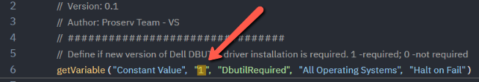

# Install instructions

1. Extract the files from the attached zip file.

2. Upload the Power Shell file to the Shared Files directory of the Managed Files folder: <https://helpdesk.kaseya.com/hc/en-gb/articles/360017878358>.

3. Import the XML into the agent procedure module: <https://helpdesk.kaseya.com/hc/en-gb/articles/229012068>.

4. Execute the procedure on a target machine.